# ***PEOPLE, PROCESSES & TECHNOLOGY***

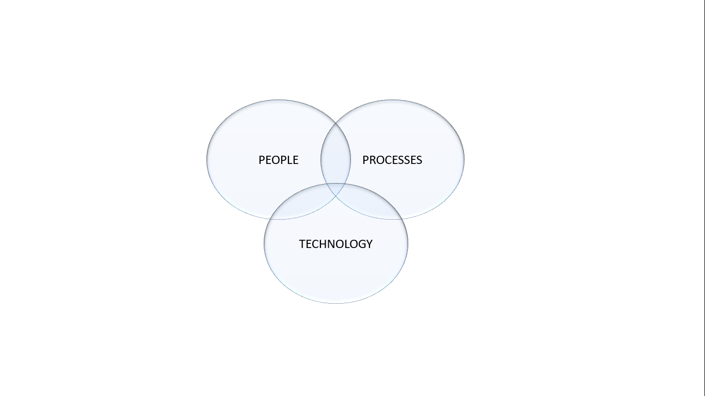

## **Points to Remember**:

1. Without technology we are nothing.
2. Without processes technology is nothing.
3. Above all if there are not people who use technology, there nothing can be done.

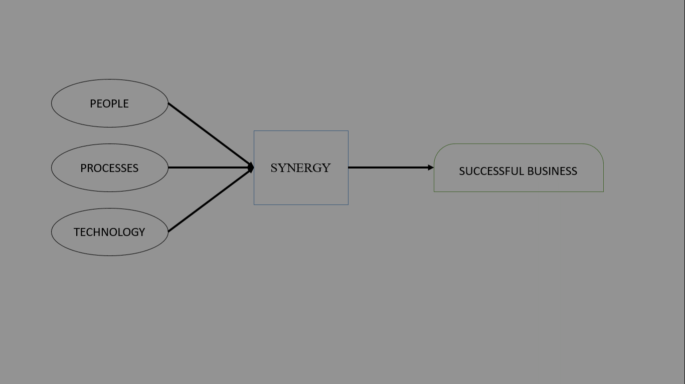

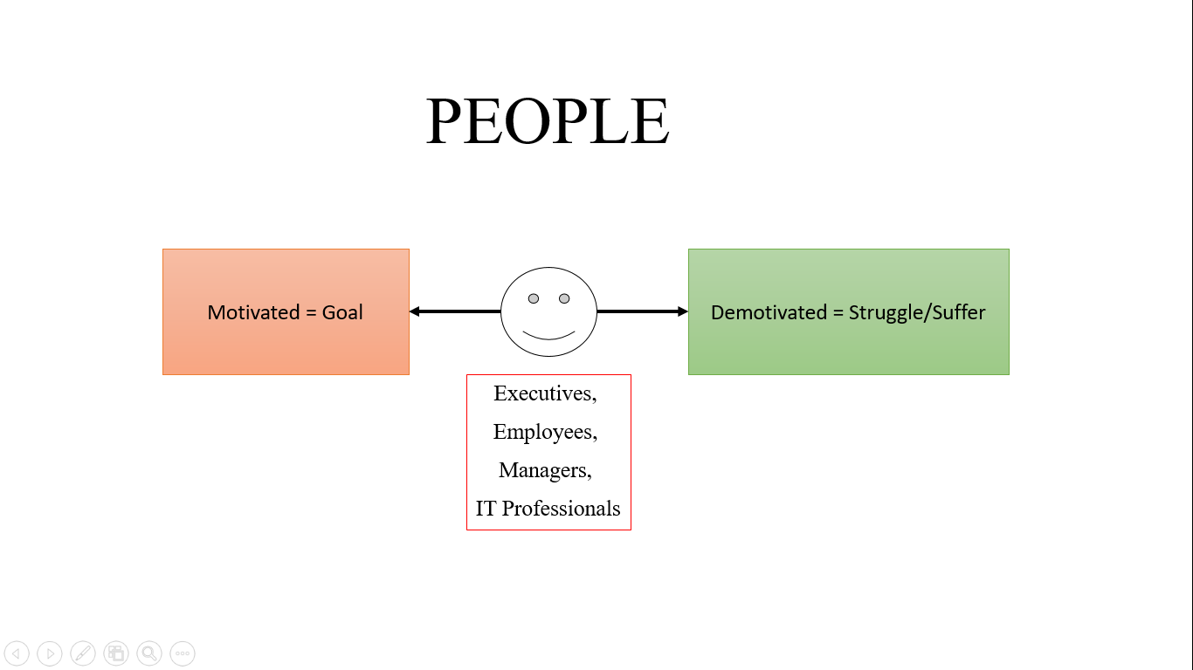

With this innovative idea for this intrusion detection system, so we satisfy the want of people and that are the end user as they are going to ultimately try our product and these end user are going to give feedback for our product. Intrusion detection system is going to offer to secure our database will satisfy the people this is help to secure our database and tools will help the people changes in our database and main important part, Any off access our database or breach the database is disallow this is to safe the database of unauthorized user is not access them, in project divided in the groups for good interaction in group for doing his work .All this work a lot of interaction in the group members. The more person in there team, the more interaction is required in there team and there is such difficulties to manages there team, the project manager must define the relationships between the roles to enable the effective coordination and control of the project. And individuals with different personalities are often expected to work together as a cohesive team. Team efficiency is often dependent on the interaction between team members and the coordination of the team leader. In team member there the better coordination is to study equally because is to give idea to more attractive or more easily to display the project to coding member is to recall the all project is more to code there no error or difficulties to face to represent to people is to easy, There is main important part to equal contribution all the team members, the more persons there is on a team the more difficult it is to communicate and share information among team members. Thus team size affects both efficiency and productivity of teams directly. In the team member motivated the other members to doing the work, there is more important to communicate manager to employees. And off the executive the project, firstly check the mistake and after finally check to show the project to the manager check the all things and check the coding and manager help to IT professional read the all project and check the code there is any mistake in code, coder is satisfy the code is to tell the project manager is satisfy.

• **People will always put their own interests ahead of the interests of the group.**

• **People are self-interested.**

• **Commercial production decisions are based on rational expectations.**

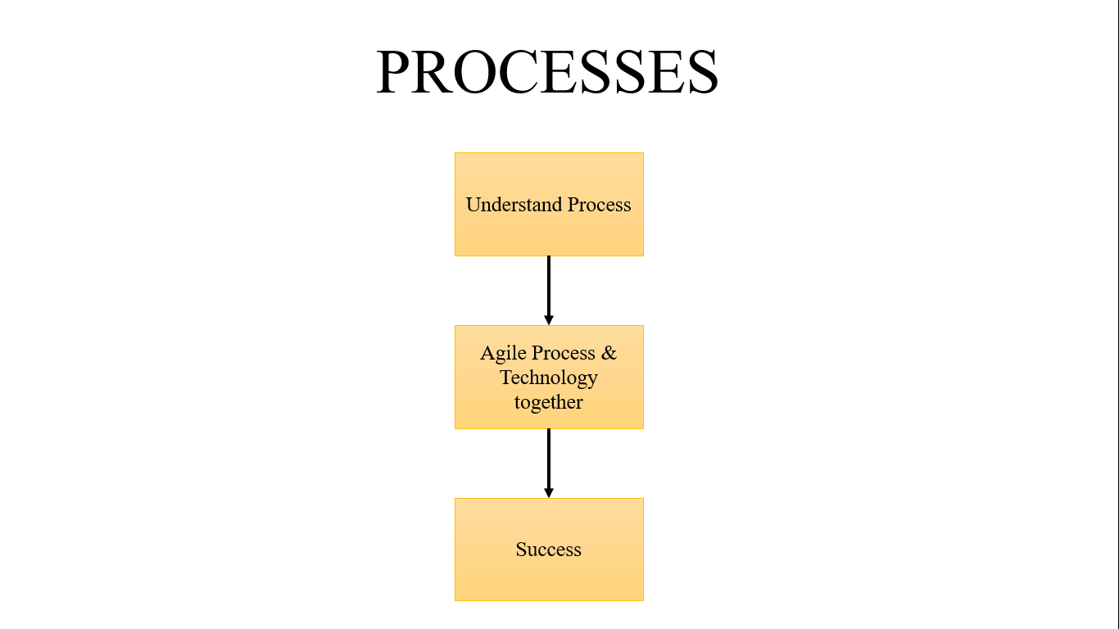

What process is to flow to development our project, In phase 1 of our project we discussed the software development and methodologies as these provide the platform for developing our project and we took one methodology that is scrum development and another main discussed about the Manifesto of agile development there is 4 point is to incorporate in our project and we discussed the flow diagram of our project and Entity relationship model and DFD explain three level [0 1 2] also. In phase 2 include the certain aspects of our project it’s the sequences of steps that is undertaken of our developer. Those process is to incorporate with the product. Those processes has certain tasks is to execute in the product. In software engineering flows the certain steps of process. Is to flow the steps and you the better Result and success achieve in the project objectives. Software process produce the high quality software and better costing. There are two major processes are include:

* **Development**: main focusing on the development software and also coordinate the team work.
* **Project management**: and focusing on the planning and also plan, in project management is flow the stages, the efficient time to complete stages in the project.

|  |
| --- |
| **TECHNOLOGY**  Upgrade using AI  Intrusion detection system security  Technology |

The technology that we will be used in the project will be **Artificial intelligences** for the requirement of the project. We have to use the Artificial intelligences from Intrusion detection system security is to secure the database using host id and password, is to upgrade the security using the AI, is access the more security in the database to secure that is add the security (fingerprint sensor, face recognition) administer using this security to add in the database is to another people not to access them, and use the storage memory to store the database for not to delete or realize any information in database.

# ETVX Specification: (PHASE 1 & 2)

1. **ETVX approach to specify a step1:**
   1. **Entry criteria**: what conditions must be satisfied for initiating this phase1

[Given this (ER diagram, DFD level 2)]

* 1. **Task**: what is to be done in this phase1

[Fulfill this conduction according to our constructor (ER diagram, DFD level)]

* 1. **Verification**: the checks done on the outputs of this phase1
  2. **exit criteria**: when can this phase1 be considered done successfully

1. **ETVX approach to specify a step2:**
   1. **Entry criteria**: what conditions must be satisfied for initiating this phase2

[Given this (pert chart and software processes)]

* 1. **Task**: what is to be done in this phase2

[Fulfill this conduction according to our constructor (pert chart and software processes)]

* 1. **Verification**: the checks done on the outputs of this phase2.
  2. **Exit criteria**: when can this phase2 be considered done successfully.